Review Panel

ON

Future Directions for
DEFENSE THREAT REDUCTION AGENCY Missions and Capabilities
to Combat Weapons of Mass Destruction

report

MARCH 2008
Preface

In August 2007, the Director of the Defense Threat Reduction Agency (DTRA) asked the Honorable Ashton B. Carter and the Honorable Robert G. Joseph to co-chair a Review Panel on Future Directions for DTRA Missions and Capabilities to Combat Weapons of Mass Destruction (WMD). The Panel was asked to conduct an independent review of, and provide recommendations on, potential future directions for DTRA, as part of the broader Department of Defense (DOD) and U.S. Government efforts to combat WMD. The Review Panel Terms of Reference are at Appendix I. Review Panel members were selected by the co-chairs; the list of
members is at Appendix II.

This is the Review Panel’s final report. The Panel is composed of independent outside experts, and the views and recommendations in this report do not necessarily reflect those of DTRA, other DOD components, other United States Government agencies, or the parent organizations of the Panel members. All Review Panel members endorse the overall thrust of this report, although not necessarily all specific views and recommendations.

The Review Panel expresses its appreciation to the many DTRA, DOD and other U.S. Government officials, as well as outside experts, with whom it met during the course of its work. The list of those officials and experts is at Appendix III. While their views and insights were invaluable, the findings and recommendations in this report are the Review Panel’s alone. Finally, the Panel expresses its gratitude for the excellent administrative support provided by DTRA staff, and especially by Mr. Robert Dickey.
I. Overview

WMD in the hands of hostile states or terrorists constitute the preeminent threat to the United States, our allies and friends. While the WMD danger may not be as immediate, on a day-to-day basis, as the other threats now facing U.S. forces in Iraq and Afghanistan, it is likely to be far closer than commonly realized, with political, military, economic and social consequences more devastating than any the United States has had to face to date.

In 2002, the President issued a comprehensive National Strategy to Combat WMD – supplemented subsequently by national strategies against biological and terrorist threats – but DOD and the U.S. Government as a whole have not fully implemented them. Performance has fallen short in all three pillars of the National Strategy to Combat WMD: prevention; protection; and response. As used in this report, “prevention, protection and response” have the same meaning as the three pillars of nonproliferation, counterproliferation and consequence management in the National Strategy to Combat WMD. Thus: prevention encompasses measures to prevent, dissuade or impede proliferation of WMD; protection, measures to deter, defend against and defeat WMD; and consequence management, measures to reduce to the extent possible the consequences of WMD use by hostile states or terrorists.

The three pillars of the National Strategy for Combating WMD in turn require three types of activities from DOD:

- First, DOD must be capable of prevailing in all WMD threat environments. Even if the enemy employs WMD, the U.S. military must be able to achieve all military objectives in all phases of the war plans in all theaters of operation. This leads to a requirement for such counters as protective equipment and missile defense, specific courses of action to fight through a WMD attack by an opponent, and effective capabilities to detect, interdict, and defeat the threat of terrorist use of WMD.

- Second, DOD must maintain a credible nuclear force to deter WMD use by hostile states, leading to a requirement for flexible, safe, secure, and effective nuclear forces maintained by appropriately trained and skilled personnel.

- Third, DOD must play an active part in government-wide efforts to prevent and protect against WMD proliferation and WMD terrorism, support threat reduction and arms control, and assist in response to WMD attacks if they occur.

Within DOD, these three activities are spread across Combatant Commands (COCOMs) (including Strategic Command [STRATCOM]), the Joint Staff, the Office of the Under Secretary of Defense for Policy, the Office of the Under Secretary of Defense for Acquisition, Technology and Logistics (AT&L), and the Military Services. The Review Panel found that, while there is awareness within the Department leadership of the importance of combating WMD, its component activities are not well defined, nor are the roles and responsibilities of the various DOD components for accomplishing them. The third type of activity involves the U.S. Government as a whole, extending across the interagency community from, in particular, the White House to the Departments of State, Energy, Homeland Security, Health and Human Services, and the Intelligence Community. Here too, the Panel finds that roles and responsibilities are not well defined, and in particular DOD’s role is not well defined. It is within this context that DTRA’s unique capabilities are brought to bear. While DTRA supports all of the DOD components and the interagency community involved in combating WMD, no one takes responsibility for building and supporting DTRA’s capabilities.

Given the breadth of combating WMD missions, and the existing gaps in their implementation, the Review Panel focused not just on DTRA, but also on broader DOD and U.S. Government efforts in the area. In fact, these are to a notable extent coterminous, because DTRA offers a unique asset to DOD and the entire U.S. Government for combating WMD. It alone in the U.S. Government has a mandate for combat support, operations, and research and development which extends to all three pillars of the National Strategy and all three WMD threats – chemical, biological and nuclear.

Although DTRA has performed well, especially in recent years, it has not been given the means required to meet all of its current responsibilities, let alone to realize its full potential for the U.S. Government in combating WMD. DOD has experienced major budget growth since the attacks of 9/11, but DTRA’s funding levels during that period have been only slightly over the inflation rate. Moreover, legislative and regulatory restrictions on the Agency’s budget seriously hinder optimal allocation of its limited resources.

DTRA’s funding limitations reflect – and reinforce – a broader issue. The Agency, and combating WMD missions in general, need powerful advocates within DOD who recognize the importance of these missions and of DTRA’s unique potential to support them. In view of the range and cross-cutting nature of DTRA’s mandate, the STRATCOM Commander, the Under Secretary of Defense for AT&L, and the Under Secretary of Defense for Policy should all be strong advocates for the Agency to gain the necessary financial resources and attention from DOD and U.S. Government senior leadership. These multiple advocates are all required; no one of them should defer the responsibility to another.

This report recommends a significant expansion of DTRA’s contributions to the combating WMD missions across the spectrum of prevention, protection and response. The Review Panel’s recommendations are numerous and wide-ranging. First, they cover DOD missions to combat WMD: deterrence and countering WMD in the hands of adversary states or terrorists, which are unique to DOD; as well as the broader U.S. Government efforts in which DOD does – or should – play a strong role. Second, they focus on the budgetary and organizational changes which should be made within DOD and the interagency community, for DTRA and DOD as a whole best to meet their combating WMD responsibilities.

The Review Panel would welcome it if other DOD or U.S. Government entities were willing to take on more activities associated with combating WMD, and other missions that DTRA is now performing; security and elimination of Man-Portable Air Defense Systems (MANPADS) is one example. However, the Panel has not been able to identify current DTRA mission areas that would be satisfactorily performed by others. Instead, we have found that, until now, only DTRA has shown the requisite willingness and ability, consistently and across the board. At the same time, we believe there are additional efficiencies to be found in several areas (for example, in nonproliferation assistance and medical countermeasures) from closer cooperation between DTRA and other U.S. Government agencies.

In light of the requirements for devoting significantly increased DOD resources to combating WMD and for establishing clear priorities among mission requirements, as well as the possibility of strong contributions from other DOD entities to the mission, the Review Panel recommends that DOD develop a new, more detailed combating WMD strategic plan for the entire Department, to include – but not be limited to – DTRA. The plan should address the missions of direct responsibility and importance for DOD, including its role in interagency efforts, across all three pillars of the National Strategy to Combat WMD.
II. DTRA’s Core Missions in Combating WMD

Protection

Combatant Command WMD Threat Awareness and Planning

Findings:

Regional COCOMs in most cases need to devote more attention to WMD threats. Many do not treat WMD use by adversaries as a central element of their war planning, exercises, and theater security cooperation programs. Those that do focus primarily on chemical and biological threats and on WMD elimination. While those are important, regional COCOMs should also give more emphasis to nuclear threats and to fighting through a WMD environment. A closer relationship between the COCOMs and DTRA could help raise WMD threat awareness within the COCOMs and enhance planning for WMD contingencies.

Recommendations:

The existing STRATCOM mandate as the lead combatant commander for “integrating and synchronizing” DOD in combating WMD should be made more concrete and operational. The current mandate is overly ambiguous and appears to allow COCOMs to choose when, how, and whether to involve STRATCOM -- and therefore the DTRA-based Strategic Command Center for Combating WMD (SCC-WMD) -- in their planning processes, exercises, theater security cooperation programs, and the like.

The relationship between regional COCOMs and STRATCOM must remain one between supported and supporting commands. However, that does not mean that STRATCOM and the SCC-WMD should take a relatively passive role, available for help when, and only when, the regional COCOMs request. Instead, new or amended guidance should make clear that STRATCOM and the SCC-WMD must be intimately involved in all WMD-related stages of planning, exercises, other theater security cooperation activities, etc., and must concur in their courses of action related to combating WMD. CONPLAN 8099 should be revised to be more specific, providing concrete guidance to regional COCOMs. The SCC-WMD and STRATCOM should also heighten efforts with the regional COCOMs to develop national and multinational exercise programs featuring serious, realistic WMD employment scenarios – including through a new emphasis on biological and nuclear threats. Moreover, STRATCOM should be given the authority and resources to fulfill its combating WMD responsibilities effectively.

At the same time, care should be taken to avoid the possibility that other COCOMs “outsource” WMD-related matters to STRATCOM and the SCC-WMD. To help raise COCOM awareness of WMD threats on a consistent basis, the SCC-WMD should work with the Intelligence Community and STRATCOM to prepare and disseminate comprehensive briefings to individual regional COCOMs on the WMD and missile threats in their areas of responsibility, and on the technical and operational consequences of those threats for contingencies. The briefings should be frequent enough to stay up-to-date, but not so frequent as to discourage fresh looks.

To the same end, the Defense Threat Reduction University should work with the National Defense University, including the Center for the Study of WMD, and the war colleges to develop intensive, comparable combating WMD curricula which should be an important element of all senior officers’ training. As a follow-on, DTRA and the National Defense University should do the same with other elements of the Professional Military Education system.

See Section III of this report, on DTRA and DOD, for organizational and budgetary recommendations to: increase ties between DTRA and regional COCOMs; expand DTRA and STRATCOM involvement in all stages of the warplanning process; and provide the SCC-WMD with the substantially greater personnel and budgetary resources required for it to fulfill expanded combating WMD responsibilities.

International Counterproliferation Activities

Findings:

Theater security cooperation should enhance the capacity of partners individually and collectively to protect against (as well as to prevent and respond to) WMD. DTRA has had an important impact where it has been involved in international counterproliferation activities. These efforts should be substantially expanded.

Recommendations:

DTRA should heighten its involvement in the Global Initiative to Combat Nuclear Terrorism, playing a major role in interagency and multilateral fora to plan and implement Global Initiative activities, including exercises and other capacity-building activities across the spectrum of prevention, protection and response. DTRA should also continue to expand and refine its Global Initiative information portal. For both multinational and national WMD counterterrorism purposes, DTRA should work with the Intelligence Community to develop further communications mechanisms to ensure better information dissemination and improved reachback for WMD counterterrorism requirements and activities.

The STRATCOM decision to transfer its Proliferation Security Initiative (PSI) leadership responsibilities to the SCC-WMD was welcome. The SCC-WMD should maintain its regular involvement in the PSI Operational Experts Group, including its important role in helping to plan and participate in PSI exercises. The SCC-WMD should also work with other DTRA elements to develop measures to improve national and partners’ interdiction capabilities. One important possibility is training and equipping assistance for interdiction, discussed below under the Cooperative Threat Reduction (CTR) program. Another likely area would be improved information dissemination and reachback. DTRA’s reachback capability offers essential support for WMD-related interdictions, and should be expanded to cover missile-related materials as well. The ability to interdict missile-related proliferation shipments is essential; DTRA appears better positioned than any other U.S. Government element to provide the necessary real-time reachback.

Regional approaches to combating WMD should be encouraged and expanded. They could help countries work together with us to leverage capabilities and enhance capacity to participate in international counterproliferation efforts. If it proves successful, the prototype Black Sea regional program being developed by the Office of the Secretary of Defense (OSD) and DTRA could be expanded to additional regions.

Nuclear Detection

Findings:

DTRA research and development work to improve nuclear detection capabilities is critical to the overall U.S. Government combating WMD effort, including against nuclear terrorism.

Recommendations:

The current division of labor -- among DTRA, the Department of Energy/National Nuclear Security Administration, and the Department of Homeland Security/Domestic Nuclear Detection Office -- on nuclear detection research and development seems appropriate. DTRA’s nuclear detection research and development, especially on stand-off detection and active interrogation capabilities, should be expanded and consistently fully funded. This is particularly the case because other U.S. Government agencies do not devote sufficient attention to such high-risk, high-payoff work.

Nuclear Deterrence and Defense

Findings:

DTRA’s focus on, and expertise in, nuclear matters are invaluable for the maintenance of a secure and effective nuclear deterrent. The Panel is concerned at the decline in DTRA – as well as other DOD -- focus on the maintenance of an effective and reliable nuclear deterrent, and believes it should be reversed.

Recommendations:

DTRA leadership should strive to maintain the Agency’s unique personnel and expert capabilities in the nuclear area, despite the pressures of funding constraints, paucity of skilled personnel, and perceived lack of attractive career paths. To assist that effort, DTRA should work with the Department of Energy and the national laboratories to encourage development of, and solid career paths for, nuclear experts.

Above all, DTRA should revive serious work (and funding) on nuclear survivability, including efforts on electromagnetic pulse, radiation hardening and general nuclear weapons effects. The threats are real, and the consequences of the current inattention could be severe. In addition, the 2007 incident at Minot and Barksdale underscored the continued – and probably heightened – importance of the DTRA nuclear surety program. The past decision to reduce by two-thirds the number of nuclear surety inspection teams should be reversed, and the frequency of DTRA inspections should be increased to more than once every five years. The Panel also welcomes the recommendations in the February 2008 Report on the Unauthorized Movement of Nuclear Weapons by the Defense Science Board Permanent Task Force on Nuclear Weapons Surety.

Chemical and Biological Defense

Findings:

The DOD budget for chemical-biological defense programs has increased significantly in recent years, now accounting for more than half of DTRA’s budget. Much of this growth has been offset by commensurate decreases in DTRA’s work on nuclear programs. Moreover, three-fifths of DTRA’s chemical-biological defense program funds – almost one-third of the total Agency budget -- is a pass-through, directed by the Joint Program Executive Office in the Joint Staff, for which DTRA is simply the financial manager. The remainder of the funds is for basic research conducted by Military Service laboratories and other entities outside DTRA, managed by a very small DTRA staff.

Recommendations:

DTRA should continue to focus its chemical and biological defense efforts in research and development, especially in advanced development of technologies which could be deployable in the near term. In addition, DTRA should look for synergies with the Department of Health and Human Services on procurement of medical biological defense countermeasures, as well as on research and development.

The overall DTRA budget increase recommended by the Panel should allow both a continuation of its chemical and biological defense work and at least a restoration of previous nuclear activities. Consideration should also be given to a change in the current situation whereby DTRA is simply the financial manager for Joint Program Executive Office programs. If DTRA is to continue managing external research programs for chemical and biological defense, real effort should be made to add strong academic and industrial expertise to the Agency’s staff, including through assignments under the Intergovernmental Personnel Act.

MANPADS

Findings:

DTRA is currently a key player in implementing elimination and security programs for MANPADS, including programs funded by other U.S. Government departments. The overall U.S. effort in this area is seriously underfunded.

Recommendations:

Although MANPADS security and elimination do not fit within DTRA’s combating WMD missions, their threat is sufficiently severe to warrant a substantially greater effort, while also sufficiently circumscribed to reduce the risk of seriously diverting needed resources from combating WMD. The Review Panel would welcome another DOD or U.S. Government entity’s taking over this work. As long as none does so, however, the DTRA effort should be maintained and expanded, with increased funding from DOD and other agencies.

If DTRA continues its MANPADS work, the responsibility should stay with its On-Site Directorate, rather than being transferred to (and funded by) CTR. MANPADS security and elimination would divert CTR attention from WMD and missile programs, just as those should be expanded, and would risk growth into other conventional weapons areas. Further, Congress has banned CTR work on conventional weapons. An effort to overturn that ban would be counterproductive if it fueled Congressional opposition to the other legislative changes recommended below for CTR.

Prevention

Cooperative Threat Reduction

In December 2007, the Review Panel submitted an interim report on future directions for CTR. The Panel still subscribes to that report; its key findings and recommendations are summarized below, and the full report is included at Appendix IV.

Findings:

CTR has been a key element of U.S. WMD reduction and nonproliferation policy in the former Soviet states. There are strong reasons to continue the program there. To be most effective, however, CTR should undergo two important changes. First, the program should be reoriented to focus on current and future WMD proliferation and terrorism threats worldwide, not just in the former Soviet states. Second, the CTR program in Russia – and elsewhere, where appropriate and feasible -- should move from assistance to cooperation.

Recommendations:

While CTR work in the former Soviet states should remain a priority, the program should refocus and expand to eliminate/reduce, consolidate, secure, and detect WMD and related materials worldwide. The means to those ends will vary according to the threat. For example, “detection” in the biological area requires disease surveillance and reporting, rather than border monitors.

CTR should establish a quick reaction capability to respond to urgent WMD-related contingencies in permissive environments worldwide. This capability should be coordinated/rationalized with the DOD Joint Elimination Capabilities Element. Although the two will have different missions, many of their required procedures and capabilities will be similar, and might even be shared.

CTR – including but not necessarily limited to the defense and military contacts program -- should emphasize counterproliferation threat awareness and equipping, as well as counterproliferation and consequence management training and exercises. The purposes should be to build national and regional capacities for WMD prevention, protection and response, including states’ ability to participate in global efforts such as PSI, the Global Initiative, and implementation of United Nations Security Council Resolution 1540.

The 2007 National Research Council report, The Biological Threat Reduction Program of the Department of Defense: From Foreign Assistance to Sustainable Partnership, properly emphasizes the value of strong and sustained support for the CTR biological threat reduction program, including an integrated approach across U.S. Government agencies. CTR should expand cooperation with the Department of Health and Human Services (including the Centers for Disease Control and National Institutes of Health) and the Department of Agriculture to implement biological threat reduction. This cooperation will be especially important in countries wary of working with DOD and/or where naturally-occurring pathogens could threaten U.S. health security. Where it facilitates engagement with target countries, cooperation should also be expanded to relevant international organizations: the World Health Organization, the Food and Agriculture Organization, and the World Organization for Animal Health.

With the expected completion in 2008 of the Bratislava Initiative agreed by Presidents Bush and Putin, CTR projects to enhance security for Russian nuclear warheads in storage and transit will come to an end. DOD and the Department of Energy should continue to work with each other and with Russian counterparts to ensure long-term sustainability for nuclear warhead and material security. In addition, if and as required to fill gaps or accelerate existing Department of Energy and Domestic Nuclear Detection Office efforts, the CTR program should include radiation detection deployment projects worldwide. DOD should work closely with the Department of Energy and the Domestic Nuclear Detection Office to coordinate efforts.

The White House should lead a regular interagency process to ensure that all U.S. Government threat reduction assistance/cooperative programs support national goals, have clear lines of responsibility, are fully funded and supported, and fully coordinated with each other. While DOD and the Department of Energy closely coordinate their nuclear security work in Russia, the requirement extends far beyond those efforts, to include different agencies’ worldwide work in biological threat reduction, export control assistance, etc.

The requirement for close cooperation among U.S. Government threat reduction cooperative programs indicates that the DOD International Counterproliferation Program could be merged into CTR, if CTR shifts to a worldwide focus. If CTR is no longer limited almost exclusively to the former Soviet states, the primary rationale for a separate International Counterproliferation Program would disappear.

Several legislative changes would enhance CTR’s ability to counter global proliferation threats, increasing its flexibility to adjust funding to meet emerging needs:

- Single annual authorization and appropriation for the program as a whole. Failing that, DOD should request funds specifically for work outside the former Soviet states;

- Ideally, provision of “notwithstanding authority” comparable to that enjoyed by the State Department’s Nonproliferation and Disarmament Fund. Failing that, provision for specific high-priority cases;

- Authorization to co-mingle foreign funds with CTR; and

- Authorization if required for the quick-reaction capability recommended above.

To streamline the CTR obligation process, DOD should:

- Assess on a case-by-case basis the need for umbrella agreements with controversial provisions, such as liability protection, privileges and immunities, etc.;

- End the requirement to amend implementing agreements to increase funds; and

- Review the obligation process overall to determine other means to streamline it.

Arms Control, Including Verification

Findings:

No matter what the future requirements for traditional arms control treaty verification and inspection tasks, the skills and facilities of the DTRA On-Site Directorate will remain highly valuable, including for less traditional tasks. Foreign Area Officers with linguistic and cultural expertise beyond the former Soviet states will become a more important asset for the On-Site Directorate, in light of the proposed geographic expansion of DTRA engagement.

Recommendations:

The DTRA On-Site Directorate could be used for logistics and audit/examination arrangements for CTR worldwide. The Directorate’s infrastructure and skills would be directly applicable to these requirements, and facilitate the recommended expansion of CTR’s scope. As the opportunity arises, the On-Site Directorate could also be used for logistics and monitoring/verification of other WMD and missile disablement, dismantlement and elimination requirements. Monitoring of any more extensive disablement and dismantlement in North Korea would be an important example.

While the On-Site Directorate’s work in arms control verification has been in permissive environments, consideration should be given to using its skills to assist COCOM eliminations in more difficult theaters (e.g., Iraq), although not in active wartime environments. Here as well, close coordination and work with the DOD Joint Elimination Capability Element should be encouraged.

The On-Site Directorate should establish and maintain close working relationships with international organizations which have verification and monitoring tasks. For example, it should participate in U.S. Government verification-related briefings to the International Atomic Energy Agency and the Organization for the Prohibition of Chemical Weapons, and might detail personnel to these organizations as “cost-free experts.”

Intelligence Support

Findings:

The initial definition of DTRA as a passive consumer of intelligence is outmoded. While progress has been made, DTRA should become more involved in both sharing information with the intelligence community and in helping it to refine and implement WMD counterproliferation and counterterrorism intelligence requirements.

Recommendations:

DTRA should work closely with the National Counterproliferation and Counterterrorism Centers on intelligence requirements for WMD counterproliferation and counterterrorism, including research and development, monitoring and verification, forensics, interdiction, etc. DTRA cooperation with the Defense Intelligence Agency should be encouraged, and should also be a part of a broader DTRA-Intelligence Community cooperation in WMD counterproliferation and counterterrorism.

The challenge of WMD terrorism provides a particular opportunity and requirement for closer cooperation between DTRA and the Intelligence Community. DTRA should be a lead DOD member for the interagency WMD Terrorism Task Force recently established by the National Counterterrorism Center for strategic operational planning. DTRA personnel should also be detailed to the joint WMD Terrorism office at the National Counterterrorism Center. More broadly, DTRA should consider personnel exchange programs with: the National Counterproliferation and Counterterrorism Centers; the Strategic Interdiction Group; the Weapons Intelligence, Nonproliferation and Arms Control Center; the Department of Energy Office of Intelligence and Counterintelligence; and the Defense Intelligence Agency.

Response

Consequence Management at Home and Abroad

Findings:

DOD, and the U.S. Government as a whole, have not assigned effective responsibility for, or devoted sufficient attention and resources to, WMD consequence management, whether domestic or international. While the task is daunting (especially given the Panel’s other recommendations for expansion of DTRA missions), DTRA appears to be the only organization within DOD that is able to take on many of the technical aspects of this responsibility, in support of Northern Command (NORTHCOM) domestically and of regional COCOMs abroad. Although resources for international capacity-building in WMD consequence management will be constrained, the awareness promotion and training discussed above would help to address partner needs at only limited expense.

Recommendations:

STRATCOM and NORTHCOM, supported by DTRA, should develop jointly a proposed plan for DOD domestic and international WMD consequence management. The proposal should first be coordinated with all other concerned DOD elements (including the Offices of the Under Secretaries of Defense for Policy and AT&L, the Joint Staff, COCOMs, the National Guard Bureau, the Military Services), and subsequently cleared by a joint National Security Council/Homeland Security Council Policy Coordinating Committee.

Domestically, the plan should focus on DOD facilities rather than on civilian consequence management. The latter must remain a Department of Homeland Security responsibility, albeit one with strong DOD involvement (the magnitude of a WMD event in the United States would inevitably call for use of DOD capabilities in response). The international elements of the plan should address consequence management for U.S. forces overseas (both in war and peacetime), and for civilian populations in conflict theaters in which U.S. forces are engaged. When complete, the relevant elements of these consequence management plans should be incorporated into all regional warplans.

The proposed plan should aim to raise threat awareness – and consequent willingness to act – in DOD and potentially other U.S. Government agencies. It should cover such issues as:

- Detailed assignment of responsibilities among DOD elements for domestic and international consequence management, including budget, acquisition and personnel requirements; and

- Training and equipping the Services and NORTHCOM for domestic military consequence mitigation, as well as the Services, COCOMs, and other governments for international consequence management.

Nuclear Attribution and Forensics

Findings:

DTRA’s efforts within DOD and with other agencies to encourage development of effective government-wide nuclear attribution and forensics capabilities should be commended. The recent Presidential guidance on the subject may mark an important milestone in this area. The general division of labor, whereby DTRA focuses on post-detonation attribution, and the Departments of Energy and Homeland Security on pre-detonation, is sensible, given the roles of the different Departments.

Recommendations:

Especially in light of the new guidance, the Panel has no specific recommendations in this area, except to emphasize the importance of adequate funding for DTRA operations and research and development efforts, and of the development and maintenance of productive interagency cooperation and information sharing.

III. DTRA and DOD

Organization

Findings:

DTRA is a unique repository of expertise and experience in WMD issues, whose capabilities are important throughout the spectrum of DOD combating WMD missions. DOD leadership should assign greater priority to combating WMD issues, and therefore to DTRA, making clear assignments of roles and responsibilities for relevant activities, consistent with Presidential guidance in the National Strategy to Combat WMD and with the seriousness of the threat. Organizational changes alone would not ensure that outcome, but they could facilitate it.

Recommendations:

DTRA Reporting Structure

The Review Panel considered several alternatives for the future DTRA reporting structure. Under one approach, the DTRA Director would continue to report to the Under Secretary of Defense for AT&L, through the Assistant to the Secretary for Nuclear and Chemical and Biological Defense Programs. Under another, the DTRA Director would report instead to the Under Secretary of Defense for Policy. Under the third approach, the post of the Assistant to the Secretary for Nuclear and Chemical and Biological Defense Programs would be abolished and replaced by an Assistant Secretary of Defense for WMD Issues, to whom the DTRA Director would report. There are three variants to the third approach: the new Assistant Secretary could report to the Under Secretary of Defense for AT&L, to the Under Secretary of Defense for Policy, or directly to the Secretary and Deputy Secretary of Defense.

Each of those alternatives has distinct advantages and disadvantages. The first alternative, continuing the current structure, carries the benefits of continuity, but in doing so, would help to perpetuate a system whereby WMD issues are effectively “buried” in practice and process within DOD. Placing DTRA within the Office of the Under Secretary of Defense for Policy would help to address more effectively the numerous policy and interagency issues involved in combating WMD. However, Policy lacks sufficient expertise and personnel to guide a large technical and operational organization -- especially after the recent Policy reorganization.

After careful consideration, the Review Panel has concluded that the best choice would be to create a new Assistant Secretary of Defense for WMD issues, and further to have him/her report directly to the Secretary/Deputy Secretary. These changes would make clear that combating WMD is of central importance to the entire Department, and that it involves vital operational and policy, as well as technical, issues.

To strengthen the combating WMD structure further, if an Assistant Secretary for WMD issues reporting directly to the Secretary/Deputy Secretary is established, the DTRA Director could be dual-hatted as the Principal Deputy Assistant Secretary of Defense for WMD. There might be some difficulties attendant on that change, requiring a balance between the strong demands of running DTRA and of fulfilling a central function within OSD. However, those disadvantages likely would be outweighed by the benefits for combating WMD of integrating the Agency better into the senior DOD structure.

No matter what choices may be made about the future DTRA reporting structure, DTRA must have powerful advocates – the STRATCOM Commander, the Under Secretary of Defense for AT&L, and the Under Secretary of Defense for Policy – who can argue effectively for the importance of DTRA’s combating WMD missions and for DTRA to receive the resources required to fulfill them. Moreover, changes to the reporting structure would be meaningless unless the Secretary, Deputy Secretary and other senior DOD officials pay close attention to combating WMD requirements.

Relationship with COCOMS

The DTRA relationship with STRATCOM is important for both organizations. While this relationship should be maintained and strengthened, DTRA’s ties to other COCOMs should be significantly enhanced, to help ensure higher COCOM priority to combating WMD. DTRA liaison offices should be established at the O-6 level in all regional COCOM headquarters where they do not exist, and vice versa. DTRA and STRATCOM should be involved in development of all operational war plans and all theater security cooperation programs, from the beginning of the process to the end.

DTRA Staffing

The Review Panel has also carefully considered whether the Directorship of DTRA should remain a civilian position or be changed to a three-star military officer post (as was the case for the predecessor Defense Nuclear Agency for most of its existence, and continues to be the case for several other DOD agencies, including the Defense Security Cooperation Agency and the Missile Defense Agency). Again, there are advantages and disadvantages to each approach. Keeping the post a civilian one would be consistent with, and help to further, the recommended greater policy and interagency role for the Agency. Moreover, the decline in WMD focus in the Military Services could make it difficult to identify three-star officers with the necessary technical expertise to lead DTRA. On the other hand, having the Agency led by a senior general/flag officer would strengthen and facilitate the relationships with the Services and COCOMs which are critical for DTRA’s combat support missions. On balance, the Review Panel recommends that the DTRA Directorship be changed to a three-star military position, if the recommendations above for an Assistant Secretary reporting directly to the Secretary/Deputy Secretary are implemented.

If the DTRA Director remains a civilian, OSD, the Joint Staff, and STRATCOM leadership should encourage the Services to nominate strong two-star officers for the DTRA Deputy Director. More generally, they should encourage the Services to help staff DTRA at the necessary rank and skill levels. Both would be facilitated by the changes recommended in this report to enhance DTRA’s role in combating WMD missions. If organizational changes do not result in placing DTRA in the Office of the Under Secretary of Defense for Policy, a DTRA Deputy Director should be detailed from senior Policy ranks.

Several other internal DTRA staffing changes should be pursued or considered. First, and most important, the SCC-WMD should be significantly expanded, Its current staffing is too small to perform the tasks outlined in this report – whether with STRATCOM, other COCOMs, other U.S. Government agencies or other governments. Second, with the expected or recommended changes in CTR and verification activities, consideration should be given to merging the DTRA On-Site and CTR Directorates, given the similarity of skills and missions increasingly required by the two; or to realigning their missions and/or personnel. Finally, DTRA staffing in chemical and biological weapons issues should be increased, although not at the expense of the nuclear expertise for which DTRA is particularly valuable within DOD.

Funding

Findings:

The current DTRA budget is constrained for its current tasks, and would be even less adequate for the recommended expansion in its combating WMD missions. DTRA funding has remained relatively flat in real terms, while the DOD budget as a whole has grown substantially. Moreover, funds cannot be shifted as required from one of the three agency budget allotments to another. There are even constraints on the ability to shift funds within some individual DTRA programs. Finally, as mentioned above, three-fifths of the chemical and biological defense program funds are not managed by the Agency.

Recommendations:

The expansion of missions recommended in this report will require a substantial increase in DTRA’s annual budget. Further, the current restrictions on the agency’s ability to shift funds among different accounts should be lifted, if necessary through legislative change. Finally, to facilitate budget obligation and expenditure, especially for urgent requirements, DTRA should be granted high-level independent contracting authority, as the predecessor Defense Nuclear Agency once enjoyed.

While the Review Panel recognizes the difficulties of obtaining adequate funding, especially in the current DOD budget environment, there is no alternative given the severity of current and future WMD threats and the long period in which DTRA has been underfunded. At a minimum, DTRA funding should increase enough over the next five years to make up the difference in the growth rates of the DTRA and overall DOD budgets.

The creation of an Assistant Secretary for WMD, and under any circumstances the emergence of strong DOD advocates for DTRA and its combating WMD missions, should help the DTRA Director to argue successfully within DOD for the required funds and budget flexibility. The determining factor, however, will be the degree to which the Secretary and Deputy Secretary recognize the requirement to fund adequately combating WMD for the near- and longer-term.

IV. DTRA and the Interagency Combating WMD Mission

Findings:

DTRA’s expertise and experience in technical and operational WMD issues are unique not only for DOD, but for the U.S. Government as a whole. DTRA should be recognized as a national asset, and its current interagency support role expanded, to take a central role in implementation of national combating WMD efforts.

Recommendations:

It would be appropriate and useful for DTRA to participate, as a technical and operational resource, in all meetings of the interagency Counterproliferation Strategy, Defense Policy and Strategy, and Homeland Security Policy Coordinating Committees for issues within its purview. While the Office of the Secretary of Defense and the Joint Staff should remain the official DOD members of those groups, the Review Panel believes that DTRA should be involved consistently in interagency consideration of combating WMD implementation issues.

DTRA should also participate in all relevant international nonproliferation and counterproliferation groups. As discussed above, it already plays an important role in the PSI Operational Experts Group and the Global Initiative to Combat Nuclear Terrorism. This practice should be expanded to include other fora where DTRA’s capabilities are directly relevant; the Disablement Working Group of the Six-Party Talks Disablement Working Group is an example.

The Counterproliferation Technology Coordinating Committee mandated by the National Strategy to Combat WMD should be revived at the Assistant Secretary-level, co-chaired by the NSC Senior Director for Counterproliferation Strategy and the HSC Senior Directors for nuclear and biological issues. The DTRA Director should participate as a full member. The National Strategy established the Coordination Committee to improve interagency coordination of U.S. Government counterproliferation research and development, to identify priorities, gaps and overlaps in existing programs and to examine options for future investment strategies.

To facilitate interagency understanding of the resources which DTRA can bring to bear in combating WMD, and DTRA understanding of the policy issues involved, robust personnel exchanges should be established between DTRA and agencies with strong combating WMD responsibilities. Examples include the Departments of State, Energy, Homeland Security and Health and Human Services, in addition to the personnel exchanges with the Intelligence Community recommended above.

The DTRA Director should deal directly with the Congress at senior levels to defend the agency’s annual budget requests. STRATCOM and the Offices of the Under Secretaries of Defense for Policy and AT&L should also be strong advocates for DTRA funding, within the Office of Management and Budget (OMB) and Congressional, as well as DOD, budget processes.

More broadly, the Counterproliferation Strategy, Defense Policy and Strategy, and Homeland Security Policy Coordinating Committees, with OMB participation, should consider the overall U.S. Government combating WMD budget requests in their areas, before final preparation of the President’s annual budget. The current system whereby each agency deals with OMB in isolation risks creating gaps and redundancies in the overall U.S. Government combating WMD funding. For example, the same OMB budget examiner is responsible for DOD and Department of Energy threat reduction cooperative programs, but not for State Department efforts. Overall budgets of the several agencies with combating WMD responsibilities are all addressed by different OMB elements.
V. Closing

Throughout this report, the Review Panel has emphasized the importance and unique nature of DTRA capabilities for combating WMD. DTRA has done much to advance national and international combating WMD missions, with the resources available. However, it requires substantially more budgetary resources and senior-level support to realize its full potential in helping DOD and the U.S. Government to confront the WMD threats of today and tomorrow.

This report offers many recommendations for enhanced DTRA and DOD action, across the spectrum of WMD prevention, protection and response. There are two basic requirements for their implementation. The first is strong advocacy and commitment by senior DOD leadership to the range of combating WMD missions, and to DTRA’s central place in their performance. Second, once that commitment is achieved, DOD requires a detailed strategic plan for combating WMD. The plan without the commitment would be hollow. The plan combined with the commitment would allow the recommendations for DOD combating WMD activities – including those in this report – to be operationalized in an ambitious, but realistic fashion.

APPENDIX I

REVIEW PANEL TERMS OF REFERENCE

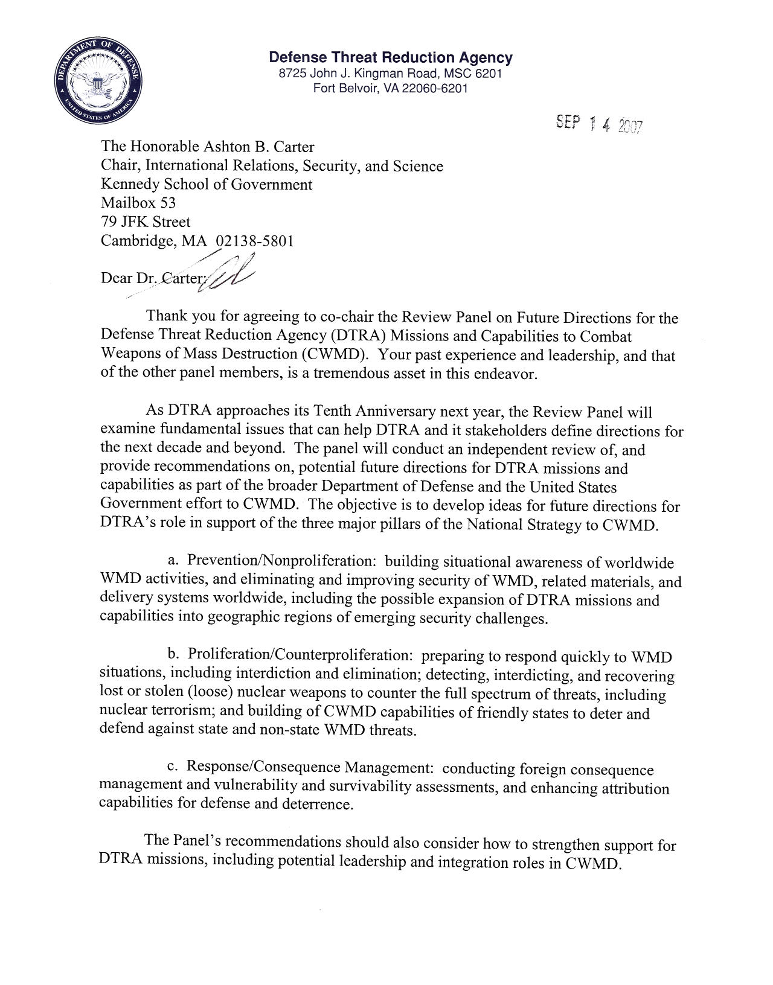
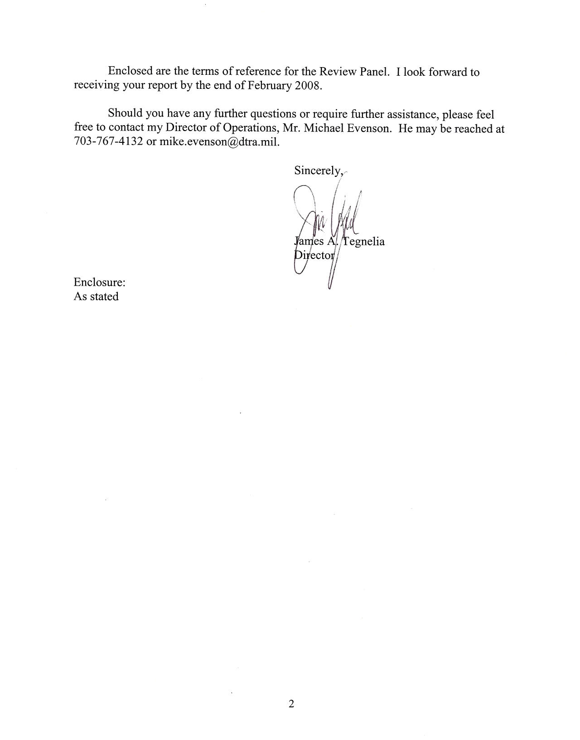
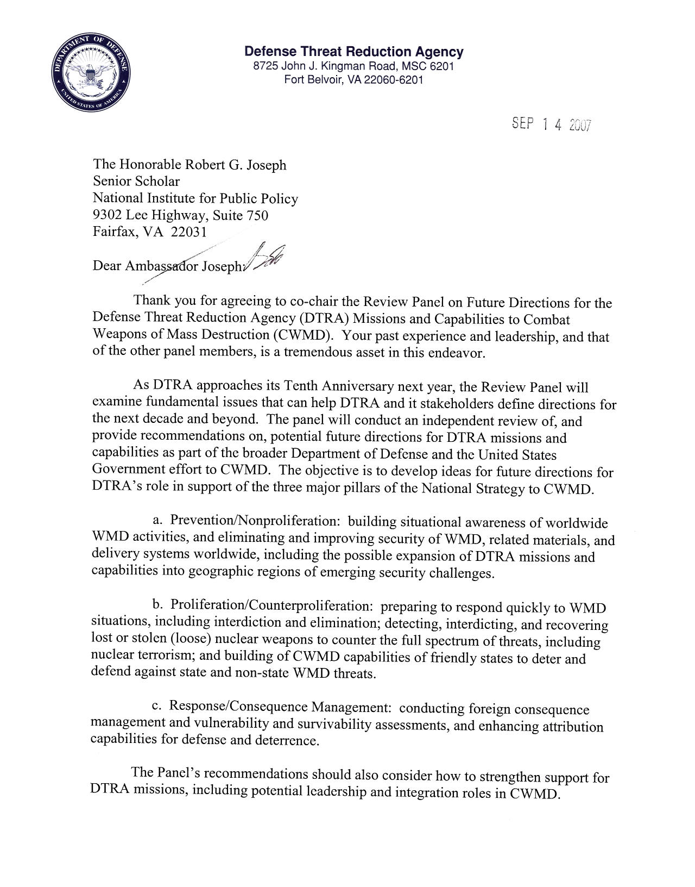
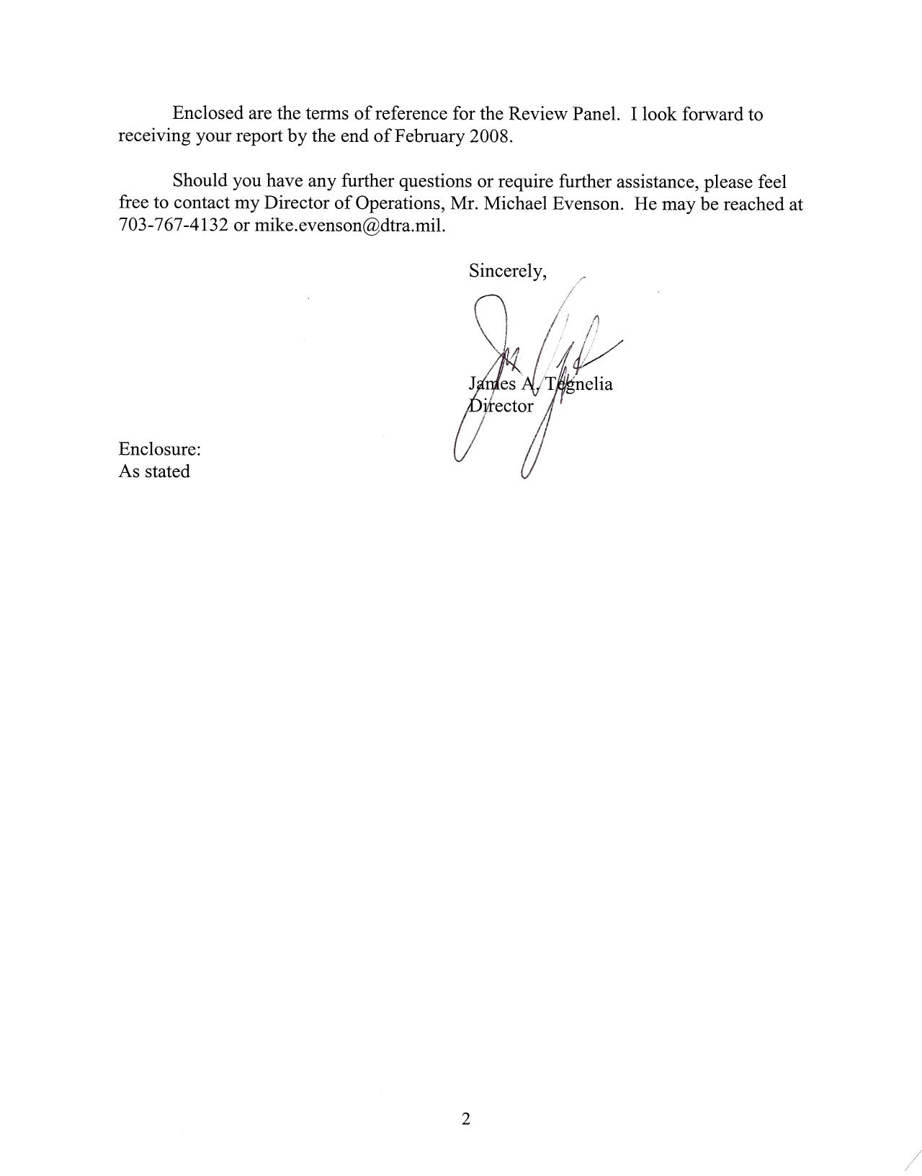
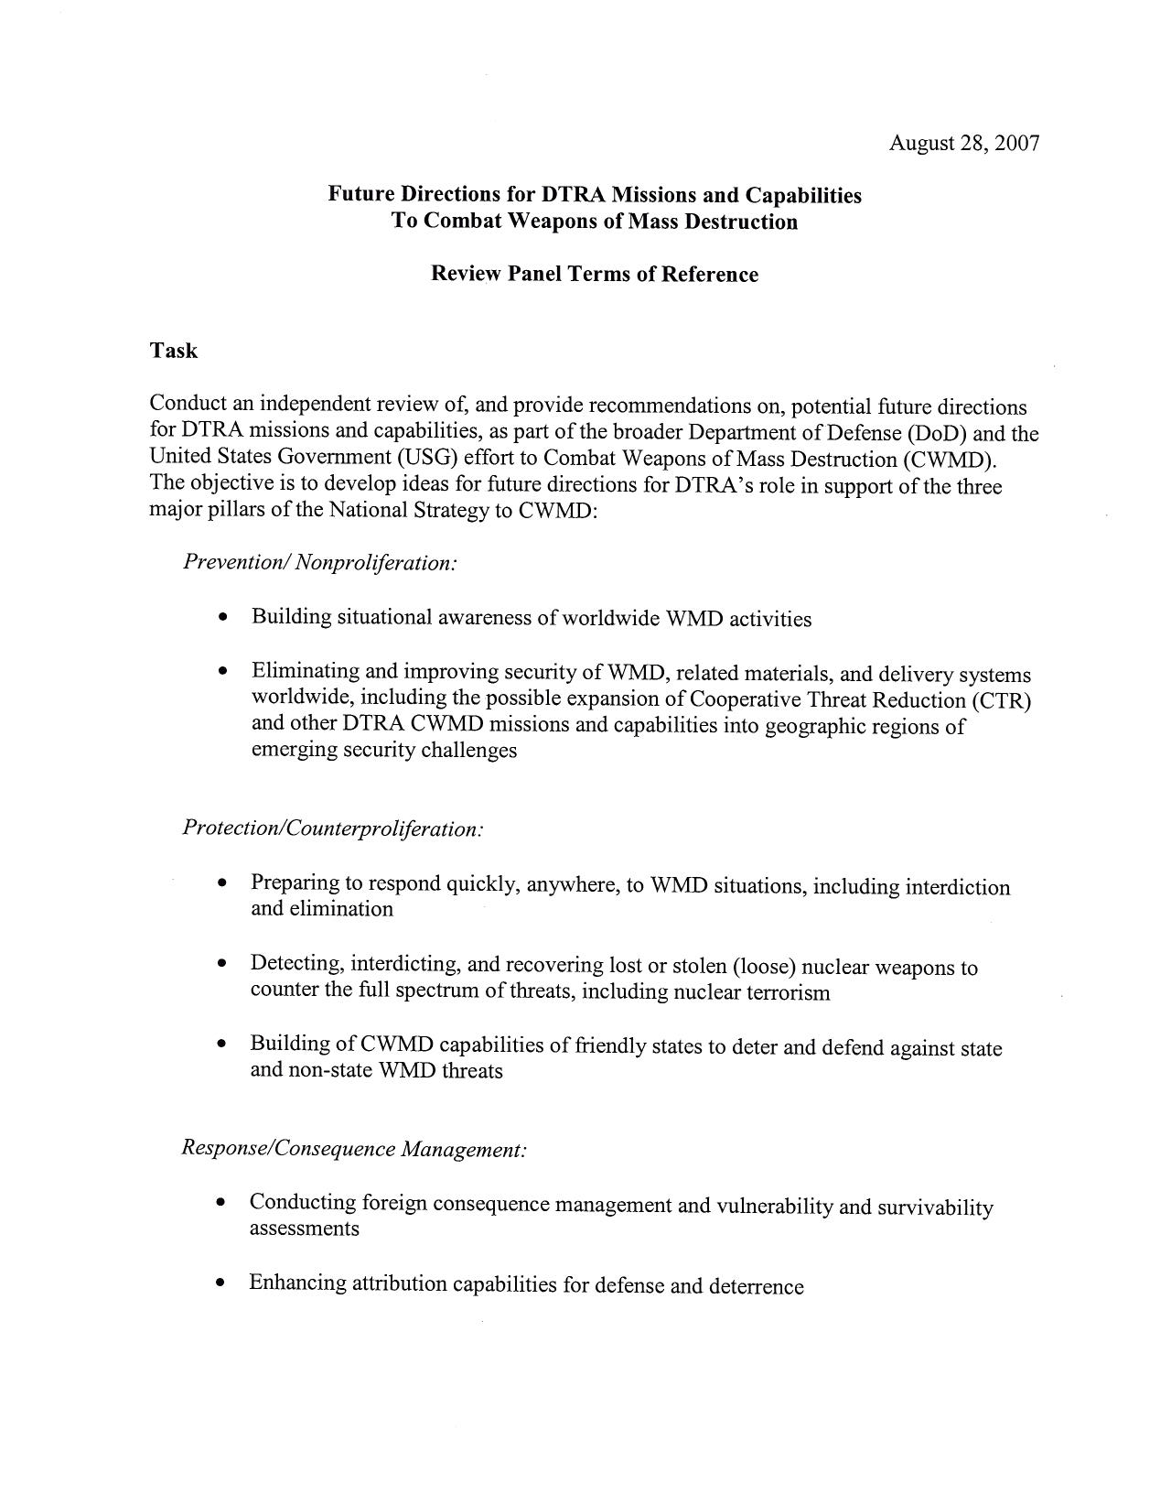
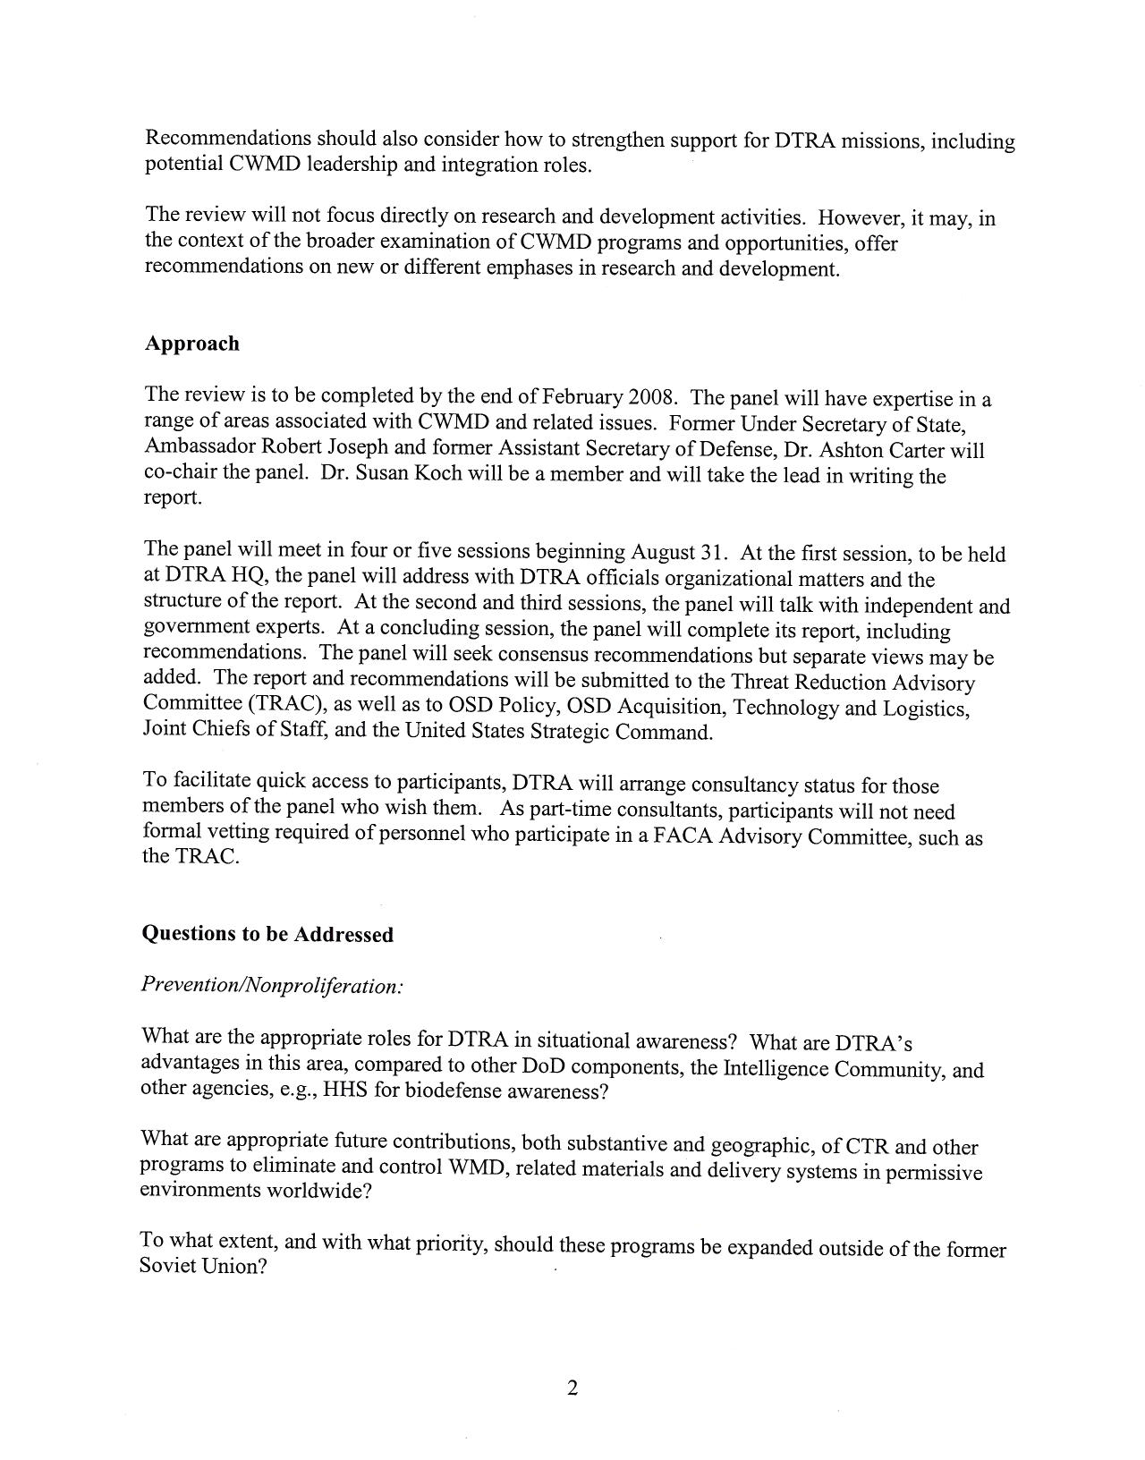
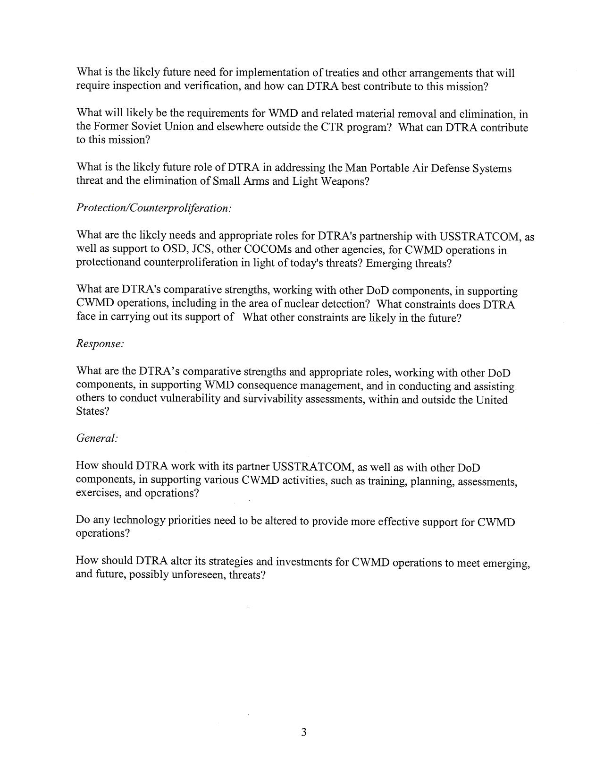
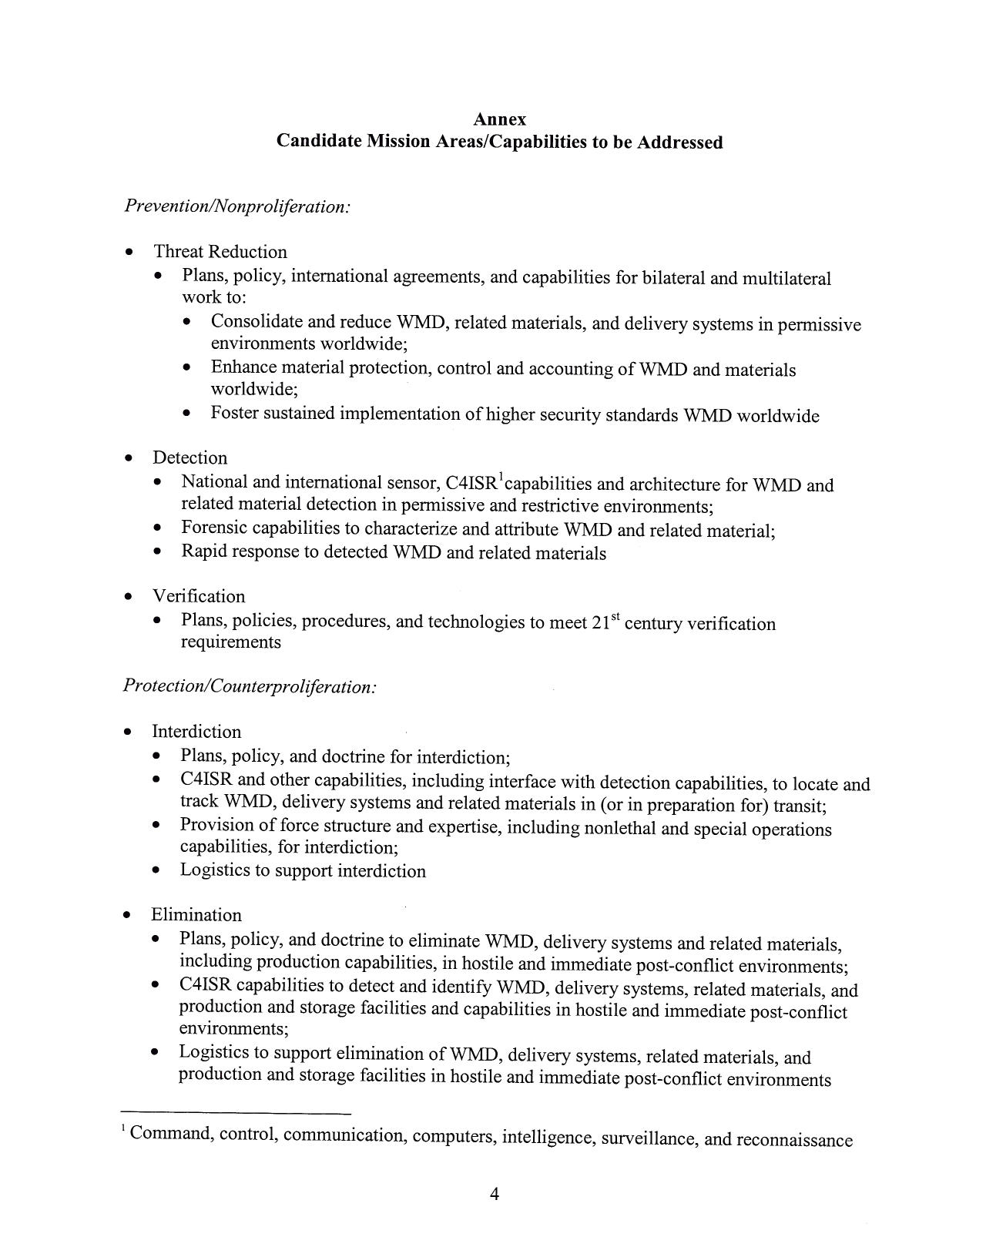
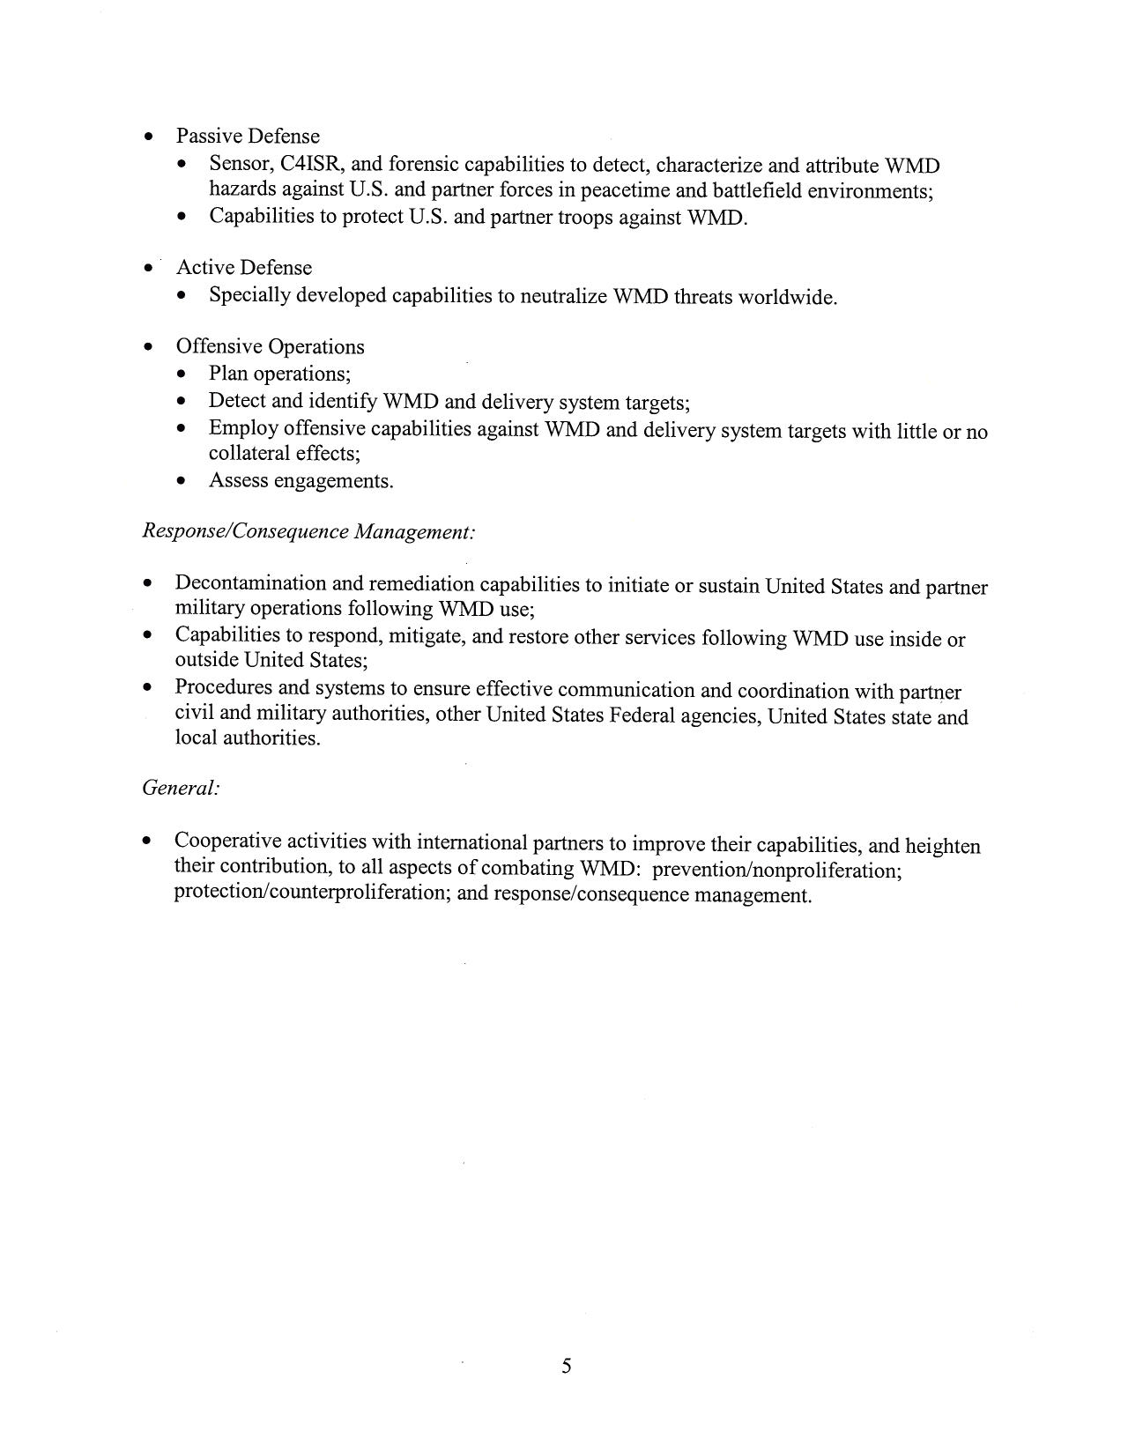
APPENDIX II
REVIEW PANEL MEMBERSHIP

Co-Chairs

The Honorable Ashton Carter. Chair, International Relations, Security, and Science, Harvard University; Co-Director, Preventive Defense Project; former Assistant Secretary of Defense for International Security Policy; Director, Center for Science and International Affairs, John F. Kennedy School, Harvard University

The Honorable Robert Joseph. Senior Scholar, National Institute for Public Policy; former Under Secretary of State for International Security Policy; Special Assistant to the President and Senior Director for Proliferation Strategy, Counterproliferation, and Homeland Defense, National Security Council Staff; Director, Center for Counterproliferation Research, National Defense University

Members

The Honorable Linton Brooks. Consultant; former Administrator, National Nuclear Security Agency, Department of Energy; Chief Negotiator, Strategic Arms Reduction Treaty; Assistant Director for Strategic and Nuclear Affairs, Arms Control and Disarmament Agency; Director, Defense Policy and Arms Control, National Security Council Staff

Ambassador William Courtney. Director, Strategy and Development, Computer Sciences Corporation; former Special Assistant to the President and Senior Director for Russia, Ukraine and Eurasia, National Security Council Staff; Ambassador to Kazakhstan and Georgia

The Honorable Charles Curtis. President and Chief Operating Officer, Nuclear Threat Initiative; former Executive Vice President and Chief Operating Officer, United Nations Foundation; Partner, Hogan & Hartson; Deputy Secretary of Energy; Chairman, Federal Energy Regulatory Commission

The Honorable Robert Einhorn. Senior Adviser, International Security Program, Center for Strategic and International Studies; former Assistant Secretary of State for Nonproliferation; Senior Adviser, Policy Planning Staff, Department of State

Dr. David R. Franz. Vice President & Chief Biological Scientist, Midwest Research Institute; former Commander, U.S. Army Medical Research Institute of Infectious Diseases (USAMRIID); Deputy Commander, U.S. Army Medical Research and Materiel Command

General John Gordon, United States Air Force (Retired). Consultant; former Assistant to the President for Homeland Security; Deputy National Security Advisor for Counter Terrorism and the National Director for Counter Terrorism; Administrator, National Nuclear Security Administration, Department of Energy; Deputy Director of Central Intelligence

The Honorable Susan Koch. Consultant; former Director, Proliferation Strategy, National Security Council Staff; Deputy Assistant Secretary of Defense for Threat Reduction Policy; Assistant Director for Strategic and Nuclear Affairs, Arms Control and Disarmament Agency

The Honorable Franklin Miller. Consultant; former Special Assistant to the President and Senior Director for Defense Policy and Arms Control, National Security Council Staff; Acting Assistant Secretary of Defense for International Security Policy; Principal Deputy Assistant Secretary of Defense for Strategy and Threat Reduction; Deputy Assistant Secretary of Defense for Nuclear Forces and Arms Control Policy

Vice Admiral David Nichols. United States Navy (Retired). Consultant; former Deputy Commander, U.S. Central Command; Commander, U.S. Fifth Fleet/Naval Forces, U.S. Central Command; Commander, Naval Strike and Air Warfare Center, Naval Air Station, Fallon NV; Executive Assistant to the Commander-in-Chief, U.S. Pacific Command

Dr. Gordon Oehler. Senior Fellow and Member of the Board of Regents, Potomac Institute for Policy Studies; former Director, Nonproliferation Center, Central Intelligence Agency

Dr. Elizabeth Sherwood-Randall. Senior Research Scholar, Center for International Security and Cooperation, Stanford University; Adjunct Senior Fellow for Alliance Relations, Council on Foreign Relations; Senior Advisor, Stanford-Harvard Preventive Defense Project; former Deputy Assistant Secretary of Defense for Russia, Ukraine and Eurasia

The Honorable William Schneider, Jr. President, International Planning Services; Chairman, Defense Science Board; Adjunct Fellow, Hudson Institute; Adviser, Center for Security Policy; former Under Secretary of State for Security Assistance, Science, and Technology
APPENDIX III
REVIEW PANEL MEETINGS

31 August 2007 – Defense Threat Reduction Agency Headquarters

Major General Randal Castro, USA. Deputy Director, DTRA
Mr. Michael Evenson. Associate Director for Operations, DTRA
Mr. Robert Gregg. Advanced Systems and Concepts Office, DTRA
Ms. Cathy Montie. Associate Director for Combating WMD, DTRA
Vice Admiral Pete Nanos, USN (Ret). Associate Director for Research & Development,
DTRA

28 September 2007 – Pentagon Conference Center

Dr. James Tegnelia. Director, DTRA
Colonel Dave Belote, USAF. Combating WMD Division Chief, Deputy Directorate
War on Terror, J-5, Joint Staff
Admiral Dennis Blair, USN (Ret). Former Commander, US Pacific Command
General James Cartwright, USMC. Vice-Chairman of the Joint Chiefs of Staff
Ambassador Eric Edelman. Under Secretary of Defense for Policy
Mr. Ronnie Faircloth. Director, On-Site Inspection Directorate, DTRA
Mr. Kenneth Handelman. Principal Director for Counternarcotics, Counterproliferation and
Global Threats, OSD Policy
Mr. Steve Henry. Deputy Assistant to the Secretary of Defense for Nuclear Matters,
OSD Acquisition, Technology and Logistics (AT&L)
Colonel David Jarrett, USA. Office of Special Assistant for Chemical and
Biological Defense Programs, OSD AT&L

31 October 2007 – Pentagon Conference Center

Mr. John Brennan. Former Director, National Counterterrorism Center
Dr. Jay Davis. Former Director, DTRA
Mr. Michael Eisenstadt. Washington Institute for Near East Policy
Dr. David Franz. Midwest Research Institute
Dr. Michael Green. Center for Strategic and International Studies
Dr. Michael Levi. Council on Foreign Relations

Dr. Kenneth Pollack. Brookings Institution

Mr. Daniel Poneman. Scowcroft Group
Ambassador Teresita Schaffer. Center for Strategic and International Studies
Dr. Judith Yaphe. National Defense University

4 December 2007 – Pentagon Conference Center

Mr. Michael Allen. Senior Director for Counterproliferation Strategy,
National Security Council Staff
Dr. Steven Aoki. Deputy Under Secretary for Counterterrorism, Department of Energy
Mr. Joe Benkert. Acting Assistant Secretary of Defense for Global Security Affairs,
OSD Policy
Ambassador Kenneth Brill. Director, National Counterproliferation Center
Dr. John Hamre. Center for Strategic and International Studies. Former Deputy Secretary of
Defense
Dr. Tom Hopkins. Acting Assistant to the Secretary of Defense for Nuclear and Chemical
and Biological Defense Programs, OSD AT&L
Senator Richard Lugar
Mr. Michael Leiter. Acting Director, National Counterterrorism Center
Mr. William Luti. Senior Director for Defense Policy and Strategy, National Security
Council Staff
Mr. Vayl Oxford. Director, Domestic Nuclear Detection Office, Department of Homeland
Security
Mr. David Shedd. Deputy Director of National Intelligence for Policy, Plans and
Requirements.
William Tobey. Assistant Administrator for Nuclear Nonproliferation, National Nuclear
Security Administration, Department of Energy
Mr. Ron Williams. Senior Director for Nuclear Threats, Homeland Security Council Staff

23 January 2008 – Pentagon

General Kevin Chilton, USAF. Commander, United States Strategic Command
Dr. Robert Kadlec. Senior Director for Biological Defense, Homeland Security Council
Staff
Mr. John Rood. Acting Under Secretary of State for Arms Control and International Security
Dr. James Tegnelia. Director, DTRA

15 February 2008 – Pentagon

Dr. Joe Braddock. Co-Chair, Joint Defense Science Board/Threat Reduction Advisory
Council Task Force on Nuclear Weapons Effects Enterprise
Admiral Richard Mies, USN (Ret). Member, Defense Science Board Permanent Task
Force on Nuclear Weapons Surety

APPENDIX IV

Interim Report on Cooperative Threat Reduction Program
December 5, 2007

Following is an interim report by the Review Panel established in August 2007 to conduct an independent review of, and provide recommendations on, potential future directions for Defense Threat Reduction Agency (DTRA) missions and capabilities, as part of the broader Department of Defense and U.S. Government effort to combat weapons of mass destruction (WMD). This interim report addresses only the Cooperative Threat Reduction (CTR), or Nunn-Lugar, Program, and does not cover other DTRA missions or capabilities to combat weapons of mass destruction. Those, along with CTR, will be addressed in the Review Panel’s final report, scheduled for February 2008.

The Review Panel is composed of independent outside experts. The views and recommendations in this interim report do not necessarily reflect those of DTRA, other DOD components or other U.S. Government agencies. The same will be true of the group’s final report in February 2008. All Review Panel members endorse the overall thrust of this report, although not necessarily all specific views and recommendations.

I. Introduction

CTR has been a key element of U.S. WMD reduction and nonproliferation policy in the former Soviet states since its inception in late 1991. To be most effective, it is essential that CTR be reoriented in those states, even more so than in recent years, to focus on current and future WMD threats, more than on dismantling the Cold War legacy of the past. There is also now a requirement and opportunity for CTR to meet some of the most pressing emerging WMD proliferation and terrorism threats elsewhere. The Review Panel believes that CTR should expand both geographically and substantively, and play a greater role in all three pillars of the National Strategy to Combat Weapons of Mass Destruction (WMD): prevention, protection, and response.

II. Russia and Other Former Soviet States

It has long been recognized that the U.S. and Russia should move from an assistance-based CTR relationship to one based on partnership and shared costs. Some large CTR investments in Russia, especially in chemical weapons elimination, are coming to a natural end. Strategic nuclear delivery vehicle and missile elimination is more complex. While that task harkens more to the Cold War legacy than to contemporary threats, and Russia is modernizing its strategic arsenal, it has also designated hundreds of strategic nuclear delivery vehicles and strategic missiles for CTR elimination through 2012 – in far greater numbers than the new systems it plans to deploy. Russia also apparently intends to turn to CTR in the event of a future requirement for more such eliminations, although given the country’s economic situation it is not clear that funding additional elimination should be a priority for the United States.

In many ways, the political and economic environment for the program in Russia is changing. Russia has a growing ability to finance arms elimination and proliferation prevention work on its own territory. Some political voices in both countries increasingly question the appropriateness or value of CTR. Internal barriers to cooperation are rising. On the other hand, the Russian Ministry of Defense continues to place high value on CTR strategic nuclear delivery vehicle/missile elimination and nuclear warhead security work, and has indicated that the decision to proceed in those areas came directly from President Putin.

As we look forward, and in the context of U.S. global nonproliferation and counterproliferation approaches, CTR in Russia should remain a priority. Despite the substantial accomplishments of CTR and related U.S. Government programs over the past 15 years, important nonproliferation and counterproliferation work remains to be done in Russia. While Russia now has the financial resources to fund threat reduction efforts and perhaps also the political will to do so, continued U.S. participation in such efforts may be the only way to ensure that they meet standards we consider adequate. Moreover, an end to -- or drastic reduction in -- CTR in Russia would almost certainly heighten Russian resistance to allowing geographic expansion of the G-8 Global Partnership – even though some Russian officials simultaneously argue that they do not need U.S. or other partners’ assistance. Further, CTR provides significant transparency into Russian military programs which is valuable in its own right, and which may become more so if and when other sources of access come to an end or are cut off by the Russian Government. By the same token, CTR provides a robust vehicle for cooperation between DOD and the Russian MOD, even as difficulties grow in other aspects of relations.

Future CTR projects could encourage collaboration with Russia to address key challenges, including security of WMD materials, WMD border and maritime security and interdiction, deactivation and elimination of excess nuclear delivery systems, and a broad range of biological threats. Thus, efforts in Russia to complete necessary security upgrades should continue, and CTR should assist Russia in ensuring long-term sustainability of those upgrades. In the long-term, helping to ensure such sustainability could be one of the greatest contributions of CTR and related Department of Energy programs in Russia. In addition, the United States should seek to expand nuclear detection sites throughout Russia and the former Soviet Union, including at all major border crossings. The bulk of the work probably will continue to be under the Department of Energy’s Second Line of Defense program, through which we have agreed with Russia to equip jointly all international Russian crossing points by 2011, but CTR and the Department of Energy should jointly consider if CTR could help to expand and/or accelerate those programs.

Although cooperation with Russia on biological threat reduction is not easy, CTR – working with the Departments of State, Health and Human Services, and Agriculture -- should continue to engage Russia on biological security and bioterrorism prevention, and expand collaborative research programs. Expansion of biological threat reduction work in other former Soviet states is also important, and less prone to political and bureaucratic obstacles. Biological threat reduction activity is of growing importance in the CTR program, with increased focus on consolidating and securing dangerous pathogens and enhancing disease surveillance.

CTR efforts remain important overall in other former Soviet states. Many retain some WMD materials, and their insufficiently secure borders may be attractive to WMD smugglers and terrorists. Those states are generally more welcoming of U.S. and G-8 assistance and most lack sufficient national resources for effective nonproliferation and counterproliferation programs. They also see considerable political and strategic benefit from close ties with the United States and other G-8 members.

The CTR Defense and Military Contacts program with Russia and other former Soviet states should be reoriented to focus on WMD counterproliferation, counterterrorism, and consequence management. DTRA and the Office of the Under Secretary of Defense for Policy, working with Strategic Command (STRATCOM), other relevant combatant commands (COCOMS) and other U.S. government agencies should develop proposals for intensive joint exercises in areas such as support of the Proliferation Security Initiative (PSI) and the Global Initiative to Combat Nuclear Terrorism, nuclear smuggling, response to disease outbreaks, consequence management, and missile defense.

III. Global CTR

The most significant required change to CTR is to refocus and expand it to other regions to help address today’s WMD proliferation and terrorism threats. This will require not only an expansion of CTR’s geographic reach, but also innovation in how it operates and its assessment of proliferation threats. A global CTR program must address proliferation risks for which the technical barriers to development, availability of materials, and skills and signatures of weapons activity vary greatly.

This refocusing and expansion should involve a concerted and coordinated global effort -- within the U.S. Government, with allies and partners in the G-8, other configurations such as PSI and the Global Initiative, and ad hoc bilateral or multilateral cooperation, and with relevant international organizations (especially the International Atomic Energy Agency and the World Health Organization). Implementation of global CTR programs, especially in counterproliferation and consequence management, will likely require more active involvement of regional COCOMs than has been the case in the former Soviet Union. However, the work must be actively led by DTRA and OSD Policy under overall U.S. Government policy guidance.

A global CTR program would be uniquely able to respond to urgent WMD-related contingencies in permissive environments. Some tasks, like Project Sapphire in Kazakhstan in 1994 or individual interdiction or Global Initiative activities, might be single-issue and comparatively quick. Others might be both multifaceted and quick, as with denuclearization in Libya. Still others might be larger, more complex and of longer duration. Until now, the U.S. Government has approached such requirements on an ad hoc basis, losing valuable time or even missing important opportunities. A quick reaction capability located in DTRA, with funding flexibility and reach -into other DOD and other agency resources under prearranged plans would significantly increase CTR’s impact on today’s proliferation threats.

Even if that quick-reaction capability and procedures are not created, DTRA/CTR’s existing skills and experience in complex WMD- and delivery system-related elimination and security tasks could have great future utility in a range of important environments. Depending on U.S. and recipient policy decisions and/or security requirements, DTRA should have a central role in such important potential applications as denuclearization and missile elimination in North Korea and Iran, and WMD and missile reduction and security in Pakistan. Whether or not those applications are likely in the near-term, DTRA’s capabilities in this area are an invaluable resource to which the U.S. Government should turn when such requirements and opportunities arise.

Reducing, consolidating and securing dangerous nuclear and biological materials will also be important CTR goals worldwide. Much biological proliferation prevention work will best be conducted in close cooperation with the Departments of State, Health and Human Services and Agriculture, as well as the World Health Organization, the World Organization for Animal Health and/or the Food and Agriculture Organization (FAO). Global nuclear work should be conducted in close coordination with DOE, including through possible use of DOD resources to help accelerate DOE’s program to remove HEU from Soviet-supplied research reactors. CTR could also help to expand worldwide nuclear detection capabilities, in support of other U.S. Government programs and of the global nuclear detection architecture now being developed by DHS.

Other important global CTR efforts – including but not necessarily limited to defense and military contacts programs -- should emphasize counterproliferation threat awareness and equipping, as well as counterproliferation and consequence management training and exercises. The purposes should be to build national and regional capacities for WMD prevention, protection and response, including states’ ability to participate in global efforts like PSI, the Global Initiative and implementation of United Nations Security Council Resolution 1540. The focus should be on enhancing capabilities against state and terrorist WMD; thus, CTR counterproliferation assistance should be available to priority states even if they have not formally endorsed PSI or the Global Initiative.

CTR, in cooperation with the Department of Energy as appropriate, should also be used to expand U.S. efforts with Russia to develop joint multilateral exercise, training and equipping programs with other states and other regions. An important starting point should be to expand on efforts under the Global and Bratislava Initiatives. Involving the International Atomic Energy Agency could facilitate these efforts. Russia’s commitment to the Global Initiative and Bratislava, and its access and influence in some countries of particular importance to their goals, might facilitate such projects, although Russia has not been eager to undertake them thus far.

Additional possibilities for global CTR might include chemical weapons destruction, missile elimination, and perhaps MANPADS/small arms-light weapons security and elimination as well as consequence management support beyond exercises (see below).

The above list is a long one – too long, given inevitable resource constraints. Therefore, priorities must be clearly established based on both the urgency and severity of the threat, and on the practical ability of CTR to work in the country concerned. In addition, the United States should continue to press G-8 partners to agree to the expansion of the Global Partnership to meet proliferation threats worldwide, as well as to the program’s extension for another 10 years (from 2012 to 2022) at a minimum funding level of $2 billion a year ($1 billion from the U.S. and $1 billion from our partners). The recommendations above regarding U.S.-Russian cooperation and leadership in global security efforts like the Global Initiative may help to bring Russia on board. So too will emphasis on our continuing commitment to Global Partnership work in Russia. Likewise, DTRA’s aligning more closely with the Department of Health and Human Services, Department of Agriculture and the World Health Organization could help improve Russia’s participation in international biological threat reduction activities.

The Fiscal Year 2008 DOD Authorization Act is likely to lift the current $50 million cap on annual CTR expenditures outside the former Soviet states. CTR should seek to budget as early as Fiscal Year 2009 (Fiscal Year 2010 may be more realistic) for activities outside the former Soviet states, rather than “taking it out of hide.” This will require DOD to pass the “psychological budget threshold” of $400 million per year – the amount that CTR has requested for most of its history.

IV. Regional Approaches

Until now CTR programs have been bilateral, but many WMD threat reduction efforts could best be implemented on a multilateral or regional basis. Such programs could help countries leverage capabilities with neighbors, develop sustainable momentum for threat reduction activities, and enhance capacity to participate effectively in international endeavors, such as the Global Initiative and PSI. OSD and DTRA are developing a prototype Black Sea regional program to combat WMD, including nuclear smuggling. CTR might contribute by providing compatible equipment to facilitate regional communication, maritime domain awareness, detection, and interdiction of WMD activities. A Black Sea program would test concepts and mechanisms which could be expanded to additional regions, such as the Persian Gulf, South Asia, Central Asia, and Northeast Asia.

Biological threat reduction may lend itself well to regional collaborations. Regional CTR efforts in Russia and Central Asia should be expanded, in conjunction with the Departments of State, Health and Human Services and Agriculture, to additional regions, such as Southeast Asia. Existing regional organizations such as the Association of Southeast Asian Nations (ASEAN) and Asia-Pacific Economic Cooperation (APEC), as well as regional offices of the worldwide health organizations may prove useful in facilitating such cooperation. When building regional public health laboratories or other biological capacity, a regional plan would facilitate regional cooperation and infrastructure sustainability.

V. Policy Leadership and Interagency Coordination

This report stresses throughout the need for close collaboration between DOD and other concerned U.S. Government agencies, other governments, and/or international organizations in implementing specific CTR projects. We must emphasize as well that CTR and all other U.S. Government threat reduction assistance programs require government-wide policy direction and coordination, under White House leadership. Program implementation can reside only with the relevant agencies. They alone have the requisite staff and expertise to execute projects, and their work could be seriously impeded by micromanagement from the policy level.

However, it is essential that the White House lead an interagency process to ensure that all U.S. Government threat reduction assistance programs support national strategic goals, are fully funded and supported within the Executive Branch and by the Congress, and fully coordinated among each other. Currently that responsibility lies with the Counterproliferation Strategy Policy Coordinating Committee chaired by the National Security Council Staff, escalating if required to the Deputies Committee and Principals Committee. P.L. 110-53 (H.R. 1 – Implementing Recommendations of the 9/11 Commission Act of 2007) provides for the creation of a White House Coordinator for the Prevention of WMD Proliferation and Terrorism. Regardless of what future organizational arrangements may be made in this area by the current Administration or its successors, policy direction and coordination for CTR and comparable programs must be led by the White House and involve all concerned agencies at a sufficiently senior level to be efficient and effective.

VI. Desirable legislative changes for FY2009

The removal this year of the annual CTR certification and the likely removal in the FY2008 DOD Authorization Act of the cap on CTR expenditures outside the former Soviet states are welcome. The following additional legislative changes would be important to enhance further CTR’s ability to transform itself from its original focus on post-Soviet dangers to a fully effective tool against today’s global proliferation threats.

First, it would be preferable if CTR’s annual authorization and appropriation specified a single figure for the program as a whole. The Department of Energy’s nonproliferation programs and DOD’s counternarcotics effort already benefit from that approach. Instead, CTR’s budget is allocated among specific project areas; while there is some ability to change those allocations this requires a time-consuming Congressional notification procedure. Whether or not Congress is willing to make that change, DOD should request funds specifically for nonproliferation work outside the former Soviet states.

Second, it would be useful if CTR could receive the same “notwithstanding” authority from which State’s Nonproliferation and Disarmament Fund now benefits. That authority would be required to work in countries where U.S. Government assistance is generally prohibited. If Congress would not support such a far-reaching change, it might agree to grant “notwithstanding” authority for specific cases.

Third, Congress should consider authorizing CTR to accept funds from other countries and to co-mingle those with appropriate CTR funds without penalty. This technique has been very useful for some specific DOE programs and would be especially valuable in helping to move CTR to a global activity. If Congress is unwilling to provide blanket authority for co-mingling of foreign funds, it could consider specific authority for nuclear and biological threat reduction work.

In addition, the Panel is considering whether to recommend that CTR program authorities be expanded in the areas of WMD consequence management and of securing and eliminating MANPADS and other small arms/light weapons.

CTR consequence management cooperation (beyond the training and exercises discussed above) would be designed to increase partners’ ability to mitigate the effects of any WMD use. In addition to that direct effect, such cooperation could help increase partners’ overall commitment to combating WMD and enable them better to deal with non-WMD disasters. On the other hand, the core constituency for CTR may question whether expansion to consequence management would divert needed resources from high priority proliferation threats – especially when CTR should dramatically expand its global non- and counterproliferation work.

U.S. Government programs to reduce the MANPADS threat are seriously underfunded. Nevertheless, the same issue of potential diversion of CTR resources from core proliferation tasks arises here as it does in consequence management. Another factor regarding MANPADS/small arms-light weapons is that the Congress several years ago specifically prohibited CTR projects on conventional weapons – a prohibition that still stands.

VII. Streamlining the CTR Process

A detailed review of the CTR agreement and obligation process is long overdue.

Requiring an umbrella agreement and individual implementing agreements makes sense where CTR expects to conduct multiple, varied, long-term efforts and expects significant obstacles to its work. It may be needlessly time-consuming where CTR work would likely focus in one or a few issue areas (e.g., biological security), or where the risk of serious obstacles is low. Therefore, DOD should assess, on a case-by-case basis, the need for detailed provisions in controversial areas like liability protection, privileges and immunities, protection from taxation, audits and examinations, etc. DOD should not accept risks to its personnel or contractors or relax controls against misuse of assistance. But it is almost certainly the case that provisions required in one country are not required in all.

In addition, DOD should end the requirement to amend implementing agreements each time a given project receives more funds, removing one, sometimes time-consuming hurdle to obligation of funds. DOD should also actively pursue other means to streamline the obligation process (whether those are internal, Congressional or international).

United Nations Security Council Resolution 1540 requires all states to criminalize WMD and missile proliferation by non-state actors, as well as to establish and enforce effective export controls and physical security for WMD, delivery systems and related materials. It encourages international assistance for implementation of the Resolution
The Department of Homeland Security and the Federal Bureau of Investigation are responsible for biological attribution and forensics.
The Panel recognizes that the creation of a new Assistant Secretary position will require Congressional approval. However, it does not believe that would be a serious obstacle, especially because the new position would replace that of the Assistant to the Secretary of Defense for Nuclear and Chemical and Biological Defense Programs, and thus would not increase the number of Senate-confirmed positions within DOD.
Those three budget allotments are: DTRA; CTR and Chemical-Biological Defense Programs. The amounts in Fiscal Year 2008 are $801.M, $425.9M and $1564.8M, respectively.
Much, if not all, CTR efforts against biological weapons threats in Russia, other former Soviet states, and elsewhere carry important public health benefits as well. Indeed, the latter may be the decisive factor in persuading many governments to cooperate in this area. Nonetheless, under existing authorities, CTR must be designed and implemented to counter WMD threats. For DOD, any additional public health benefits – no matter how significant – may not be the primary purpose of the work. At the same time, broader engagement in public health and the life sciences (in collaboration with the Departments of State, Health and Human Services, and Agriculture) may be required as CTR expands beyond into states and regions where biological weapons proliferation is a concern but our knowledge of offensive programs is poor or DOD access is limited.

